Data Structure lab assignment 1

**Problem No: 1**

**Problem Statement:** Write a C program to print an array.

**Source Code:**

#include<stdio.h>

int main () {

int n, i;

printf("Enter the length of the array: ");

scanf("%d", &n);

int arr[n];

printf("Enter the elements of the Array-->\n");

for (i = 0; i < n; i++)

scanf("%d", &arr[i]);

printf("The Array is -->\n");

for (i = 0; i < n; i++)

printf("%d\t", arr[i]);

}

**Output:**

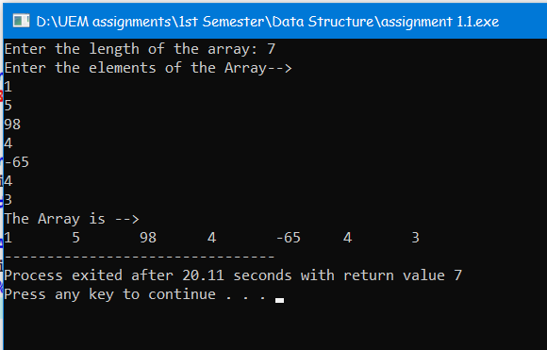

**Problem No: 2**

**Problem Statement:** Write a C program to check whether a given string is Palindrome or not.

**Source Code:**

#include<stdio.h>

#include<string.h>

int main() {

char str[100];

int l = 0, h;

printf("Enter a string: ");

gets(str);

h = strlen(str) - 1;

while (h > l) {

if (str[l++] != str[h--]) {

printf("%s is not a palindrome\n", str);

return 0;

}

}

printf("%s is a palindrome\n", str);

return 0;

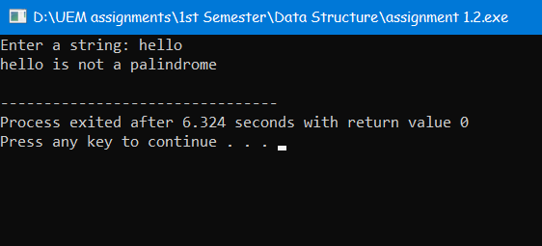}

**Output:**

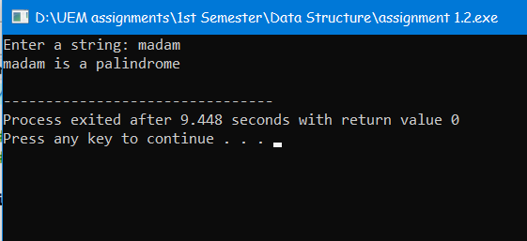

**Problem No: 3**

**Problem Statement:** Write a C program to convert temperature from degree Centigrade to Fahrenheit.

**Source Code:**

#include<stdio.h>

int main () {

int tc, tf;

printf("Enter the temperature in celcius: ");

scanf("%d", &tc);

tf = (tc * 9 / 5) + 32;

printf("%d deg C = %d deg F", tc, tf);

return 0;

}

**Output:**

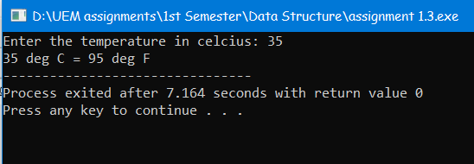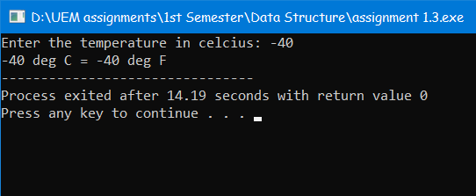

**Problem No: 4**

**Problem Statement:** Write a C program to sort an array.

**Source Code:**

#include <stdio.h>

int main() {

int i, j, temp, len;

printf("Enter the length the array: ");

scanf("%d", &len);

int arr[len];

printf("Enter the elemets \n");

for (i = 0; i < len; i++)

scanf("%d", &arr[i]);

printf("The array before sort are given below \n");

for (i = 0; i < len; i++)

printf("%d\t", arr[i]);

for (i = 0; i < len; i++)

for (j = i + 1; j < len; j++)

if (arr[i] > arr[j]) {

temp = arr[i];

arr[i] = arr[j];

arr[j] = temp;

}

printf("\nThe array after sort are given below \n");

for (i = 0; i < len; i++)

printf("%d\t", arr[i]);

return 0;

}

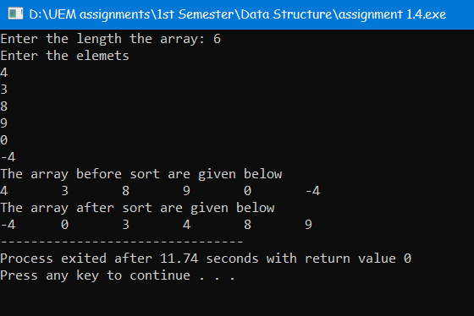

**Output:**

**Problem No: 5**

**Problem Statement:** Write a C program to print the largest and second largest element of the array.

**Source Code:**

#include <stdio.h>

int main() {

int n, max, max2, i, has_max2 = 0;

printf("Enter the length of the array \n");

scanf("%d", &n);

int arr[n];

printf("Enter the elements \n");

for (i = 0; i < n; i++)

scanf("%d", &arr[i]);

printf ("The array is->\n");

for (i = 0; i < n; i++)

printf("%d\t", arr[i]);

max = arr[0];

for (i = 0; i < n; i++) {

if (max < arr[i]) {

max2 = max;

max = arr[i];

}

}

for (i = 0; i < n; i++) {

if (arr[i] < max) {

if (!has_max2) {

has_max2 = 1;

max2 = arr[i];

}

else if (arr[i] > max2)

max2 = arr[i];

}

}

if (has_max2 == 1)

printf("\nLargest number = %d\n2nd Largest number = %d", max, max2);

else

printf("\nAll values are identical to %d", max);

return 0;

}

**Output:**

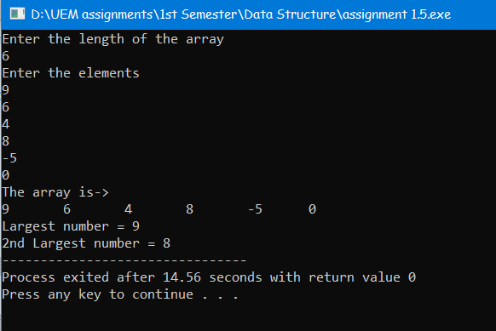

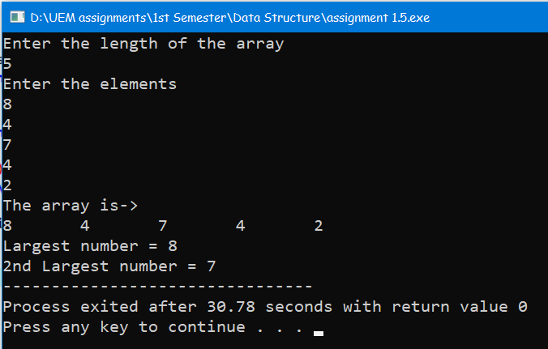

**Problem No: 6**

**Problem Statement:** Write a C program to display Fibonacci series.

**Source Code:**

#include <stdio.h>

int main() {

int num, i, t1 = 0, t2 = 1, next = t1 + t2;

printf("Enter the terms of Fibonacci Series: ");

scanf("%d", &num);

printf("Fibonacci series-->\n");

printf("%d\t%d\t", t1, t2);

for (i = 2; i < num; i++) {

printf("%d\t", next);

t1 = t2;

t2 = next;

next = t1 + t2;

}

return 0;

}

**Output:**

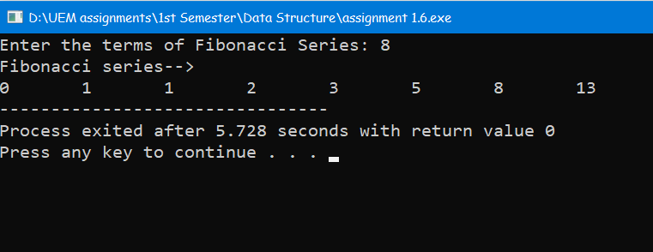

**Problem No: 7**

**Problem Statement:** Write a program that reads two 2D metrices from the console, verifies if metrics multiplication is possible or not. Then multiplies the metrices and prints the 3rd metrics.

**Source Code:**

#include<stdio.h>

int main() {

int row1, row2, column1, column2, i, j, k;

printf("Enter the row and column of the 1st Matrix-->\n");

printf("Row: ");

scanf("%d", &row1);

printf("Column: ");

scanf("%d", &column1);

printf("Enter the row and column of the 2nd Matrix-->\n");

printf("Row: ");

scanf("%d", &row2);

printf("Column: ");

scanf("%d", &column2);

if (column1 != row2) {

printf("1st matrix columns is not equal to 2nd matrix row.\nMultiplication Can't possible.");

return 0;

}

int matrix1 [row1][column1], matrix2 [row2][column2], result [row1][column2];

printf("Enter the elements of 1st Matrix-->\n");

for (i = 0; i < row1; ++i)

for (j = 0; j < column1; ++j) {

printf("Enter element at [%d] [%d]: ", i + 1, j + 1);

scanf("%d", &matrix1[i][j]);

}

printf("Enter the elements of 2nd Matrix-->\n");

for (i = 0; i < row2; ++i)

for (j = 0; j < column2; ++j) {

printf("Enter element at [%d] [%d]: ", i + 1, j + 1);

scanf("%d", &matrix2[i][j]);

}

for (i = 0; i < row1; ++i)

for (j = 0; j < column2; ++j)

result[i][j] = 0;

for (i = 0; i < row1; ++i)

for (j = 0; j < column2; ++j)

for (k = 0; k < column1; ++k)

result[i][j] += matrix1[i][k] * matrix2[k][j];

printf("Multiplication of two matrices is-->\n");

for (i = 0; i < row1; i++) {

for (j = 0; j < column2; j++)

printf("%d ", result[i][j]);

printf("\n");

}

return 0;

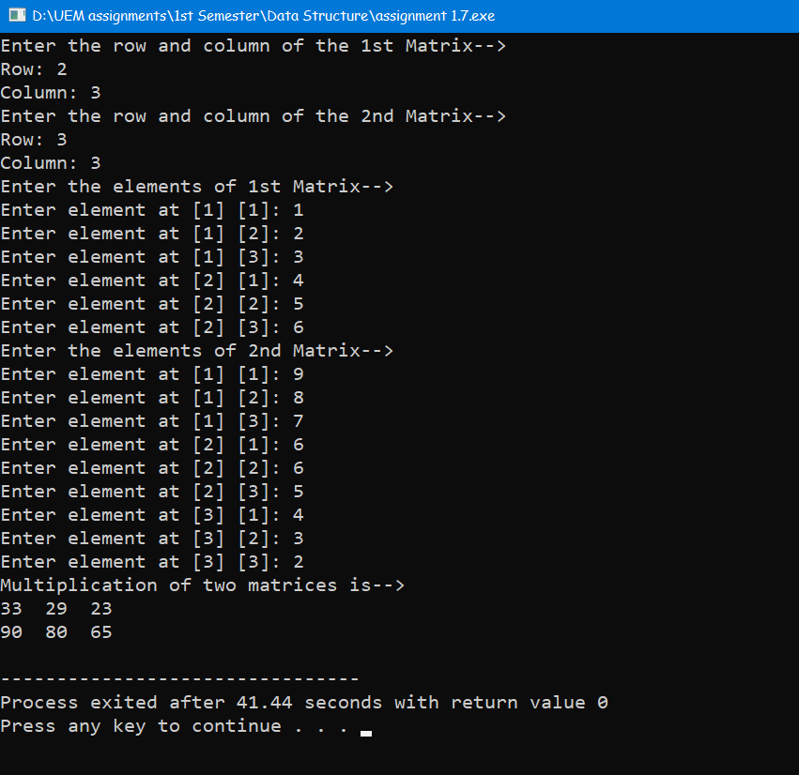}

**Output:**

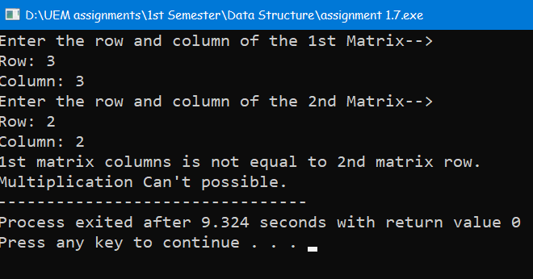

**Problem No: 8**

**Problem Statement:** Write a program that reads a 2D metrics and checks if the metrics is a symmetric metrics or not.

**Source Code:**

#include<stdio.h>

int main() {

int row, column, i, j, flag = 0;

printf("Enter the row and column of the Matrix-->\n");

printf("Row: ");

scanf("%d", &row);

printf("Column: ");

scanf("%d", &column);

int matrix [row][column];

printf("Enter the elements of the Matrix-->\n");

for (i = 0; i < row; i++)

for (j = 0; j < column; j++) {

printf("Enter element at [%d] [%d]: ", i + 1, j + 1);

scanf("%d", &matrix[i][j]);

}

for (i = 0; i < row; i++)

for (j = 0; j < column; j++)

if (matrix [j][i] != matrix [i][j]) {

flag = 1;

break;

}

if (flag == 0)

printf("The matrix is a symmetric matrix.");

else

printf("The matrix is not a symmetric matrix.");

return 0;

}

**Output:**

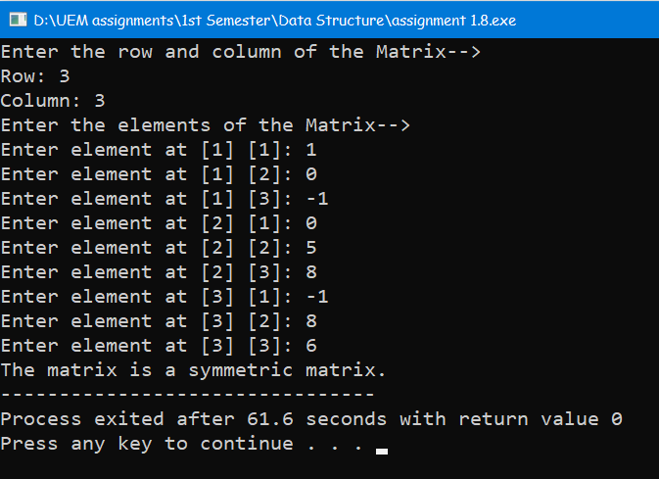

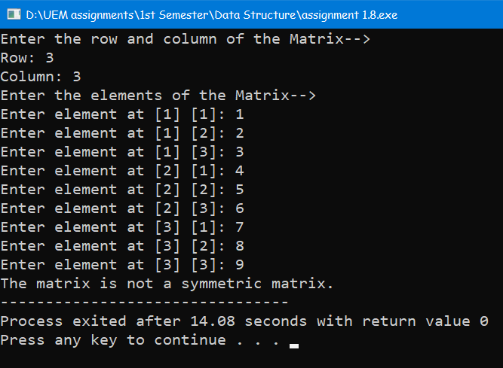

**Problem No: 9**

**Problem Statement:** Write a C program to print reverse array.

**Source Code:**

#include<stdio.h>

int main() {

int len, i;

printf("Enter the length of the array \n");

scanf("%d", &len);

int arr[len];

printf("Enter the elements \n");

for (i = 0; i < len; i++)

scanf("%d", &arr[i]);

printf ("The array is->\n");

for (i = 0; i < len; i++)

printf("%d\t", arr[i]);

printf ("\nThe reverse of the array is->\n");

for (i = len - 1; i >= 0; i--)

printf("%d\t", arr[i]);

return 0;

}

**Output:**

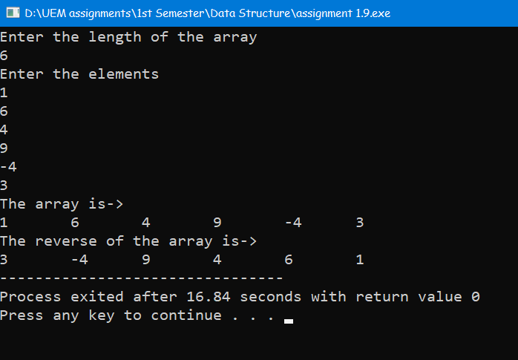

**Problem No: 10**

**Problem Statement:** Write a C program to check the sum of all elements of an array.

**Source Code:**

#include<stdio.h>

int main() {

int len, i, sum = 0;

printf("Enter the lenght of the array: ");

scanf("%d", &len);

int arr[len];

printf("Enter the elements of the array-->\n");

for (i = 0; i < len; i++) {

printf("%d element: ", i + 1);

scanf("%d", &arr[i]);

}

for (i = 0; i < len; i++) {

sum += arr[i];

printf("%d + ", arr[i]);

}

printf("\b\b= %d", sum);

return 0;

}

**Output:**

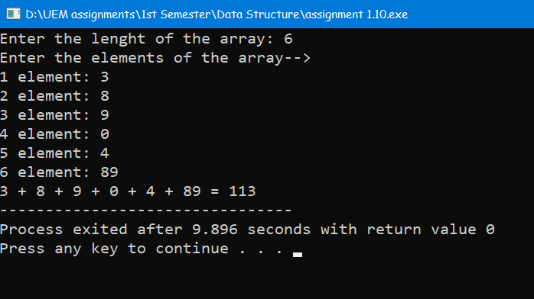

**Problem No: 11**

**Problem Statement:** Write a C program to check duplicate number in an array.

**Source Code:**

#include <stdio.h>

int main() {

int len, i, j, count = 0;

printf("Enter the lenght of the array: ");

scanf("%d", &len);

int arr[len];

printf("Enter the elements of the array-->\n");

for (i = 0; i < len; i++) {

printf("%d element: ", i + 1);

scanf("%d", &arr[i]);

}

for (i = 0; i < len; i++)

for (j = i + 1; j < len; j++)

if (arr[i] == arr[j]) {

count++;

break;

}

if (count == 0)

printf("No duplicates found in the array.\n");

else

printf("Number of duplicates found in the array = %d\n", count);

return 0;

}

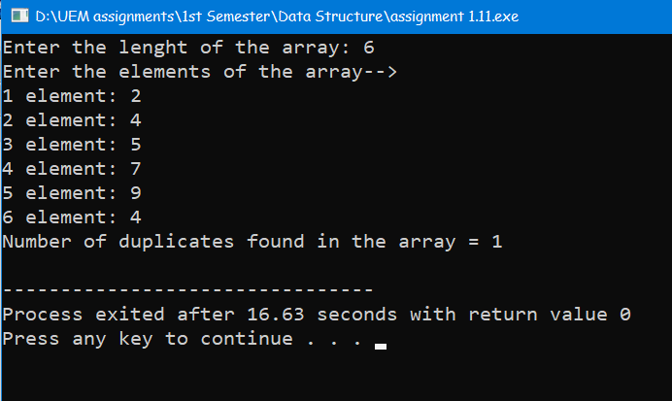**Output:**